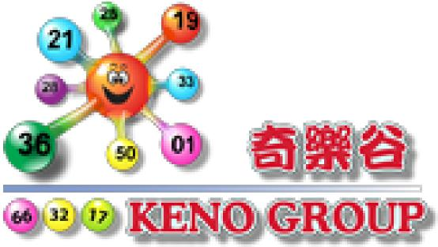

|  |  |  |
| --- | --- | --- |
| 文件版本 | 负责人 | 最后修订日期 |
| 1.1 | Jay | 10/01/2012 |
| 1.2 | William | 25/08/2012 |
| 1.3 | Wiliam | 15/05/2013 |

KG 接 口 规 范 (API)

**目 录**

1. 取盈亏表 3

1.1 API 接驳口 URL 4

# 1. 取盈亏表

|  |  |  |  |  |  |
| --- | --- | --- | --- | --- | --- |
|  | | | Check PNL | |  |
| <标记> | * | <类型> |  | <说明> |  |
| VendorId | * | int(10) |  | Kenogroup分配给网主的id |  |
| Date | * | Date |  | 盈亏表的 日期时间 |  |
| HourType | * | Int(1) |  | 1 is 12:00:00-12:00:00, 2 is 00:00:00 - 23:59:59  – 23:59:59 | |

|  |
| --- |
| XML Structure Example |
| Call Strcuture |
| <?xml version="1.0" encoding="iso-8859-1"?>  <methodCall>  <methodName>GetPNL</methodName>  <params>  <param>  <value>  <struct>  <member><name>**VendorId**</name><value><string>XXX</string></value></member>  <member><name> **Date**</name><value><string>XXX</string></value></member>  <member><name> **HourType**</name><value><string>XXX</string></value></member>  </struct>  </value>  </param>  </params>  </methodCall> |
| Success Response |
| <?xml version="1.0" encoding="iso-8859-1"?>  <methodResponse>  <params>  <param>  <value>  <array>  <data>  <value>  <struct>  <member><name>**PlayerId**</name><value><string>xxx</string></value></member>  <member><name>**Total_Stake_Accurate**</name><value><string>xx</string></value></member>  <member><name>**Total_PNL**</name><value><string>xxx</string></value></member> </struct></value>  </data>  </array>  </value  </param>  </param>  </methodResponse> |

|  |  |
| --- | --- |
| Fail Response | |
| <?xml version="1.0" encoding="iso-8859-1"?>  <methodResponse>  <params>  <param>  <value>  <struct>  <member><name>**Error**</name><value><string>XXX</string></value></member>  </struct>  </value>  </param>  </params>  </methodResponse> | |
| Fail: status false with error reason | |
| VENDOR NOT AUTHORIZED | xmlrpc访问的IP与网主的设置不匹配 |
| VENDOR ACCOUNT SUSPENDED | 网主帐户暂停 |
| VENDOR ID NOT VALID | 网主id（整数) |
| DATE FORMAT NOT VALID | 日期格式： 2012-01-10 |
| HOURTYPE NOT VALID | 1 is 12:00:00-12:00:00, 2 is 00:00:00 – 23:59:59 |
| DATE NOT VALID MUST BEFORE THAT | 日期必须在当前日期之前。 |

## 1.1 API 接驳口 URL

KENO ： http://integrate.v88kgg.com/player_pnl.php

时时彩(SSC) ： http://integrate.v88kgg.com/player_ssc_pnl.php